CR TITLE | VENDOR STATUS TO BE CHANGED AUTOMATICALLY TO ¨PAYSITE¨ ONCE THE ¨ONE-TIME VALIDITY EXPIRATION DATE¨ IS REACHED IN SAM
Submitted on : | 12/05/2026

All sections are mandatory. When not applicable, please mention ‘N/A’.

REQUESTOR INFORMATION
(To be provided by CR Requestor)
First Name & Last Name | Paulina Kłeczek, Paulina Pietrzyk, Berenika,
Region | Europe
E-Mail Address | paulina.kleczek@capgemini.com, paulina.pietrzyk@capgemini.com

VERSION HISTORY
(To be provided by CR Requestor)
Document Version | Document Update Date | Document Updated By | Approved By
1.0 | 12/05/2025 | Maria S | Antonio G
2.0

CHANGE REQUEST MAIN INFORMATION
(To be provided by CR Requestor)
GIT Procurement Applications | SAM
Legal Requirement | No
Legal Requirement Description | NA
Legal Requirement Deadline | NA
Requested Implementation Date | Standard
Purpose of the CR | New Functionality
Component Number & Name (if applicable) | NA
Module(s) Names (if applicable) | sUPPLIER
ServiceCentral Ticket (if applicable) | NA

CHANGE REQUEST BUSINESS VALUE
(To be provided by CR Requestor)
Will this change help Business teams comply with Legal mandate?  (Example: GDPR / Enhance security / any other industry mandate) | No
Will this change simplify the workflow of the application and thus lead to benefits like time reduction by approx. 50% or more?  (Example: Reduce redundant or complex workflows of application) | Yes
Will this change help Business teams in long term as the application is not planned for decommissioning in near future? | Yes
Will this change automate an existing manual task and thus lead to cost reduction by approx. 50% or more?  (Example: Change that will reduce time and manual dependency in turn lead to substantial cost reduction) | Yes
Will this change help increase End user satisfaction and lead to subsequent reduction in tickets (approx. 50% or more) ?  (Example: Changes that will enhanced User experience and accessibility) | Yes

CHANGE REQUEST TIME CRITICALITY
(To be provided by CR Requestor)
Is the change expected by Business team on a fixed date due to Business milestones like appraisal cycles, year end activity etc?  (Example: The change is expected on a fixed date, which can enable Business to use the change; delay in providing the change may result in application not be used) | No
Is the change related to integrations with other applications and expected as per synchronized plan?  (Example: Interdependent solution involving multiple applications where unsynchronized build will cause the complete integrated solution incapable of use) | Yes
Will the delay in implementing change impact the application usage by End-user ?  (Example: Change that will reduce an additional tracking end user has to perform) | No

CHANGE REQUEST DETAILED DESCRIPTION
(To be provided by the Change Request Requestor)
One-Time Vendor is a supplier profile created exceptionally for occasional or designated purchases, with short validity period (up to 3 months). It is “infrequent use supplier”, and is systematically deactivated for PR/PO creation after the validity period is completed. System Identification: “One-time vendor” ticked in SAM.

When the One-Time Vendor Expiration Date is reached:
- Change all Regional Statuses of Parent and Child Supplier to Paysite automatically.
- Vendor Global Status remains Active. For both parent and child
- This applies only to vendors correctly tagged as One-Time Vendors and their sites.
- If a Group Supplier is tagged as a One-Time Vendor, this is considered a data quality issue and should be corrected by OBO.
- A One-Time Vendor will be subject to the standard Supplier Cleansing Process as defined in the Supplier End-to-End Lifecycle document when all of the following conditions are met:
  - Supplier status is “Active” • No PO for 15 months • AND, No Invoice for 15 months • AND, Supplier not created in the last 60 days • AND, no Requisitions created in the last 60 day
- When the above conditions are met:
  - Parent and Child Vendor Global Status changes automatically to Locked.
  - Regional Statuses of the Parent and Child Supplier change to Blocked.
  - Closure Reason: One-Time Vendor – Validity Expired.
New Closure Reason to be added in SAM:
One-Time Vendor – Validity Expired
Note:
- in case the One time vendro expiration date is postponed then the calculation should happen based on the new Validity date.
- Vendor status update should interface to downstream apps, as per the logic existing today.

Attachments:
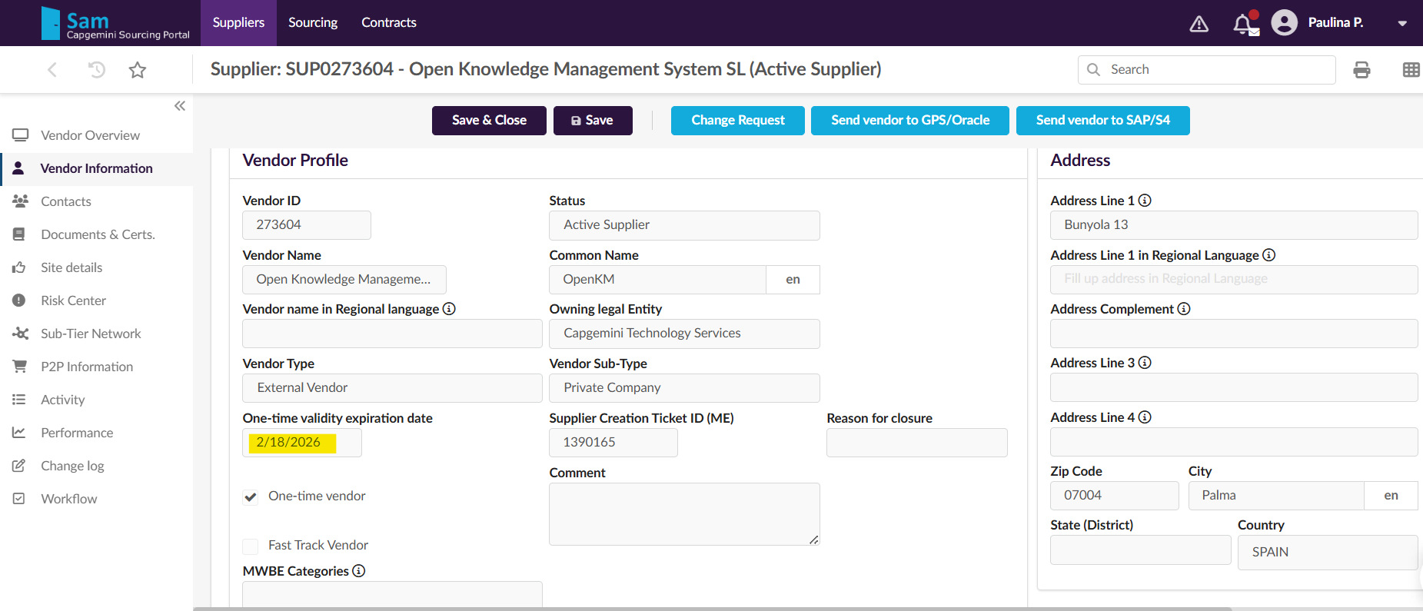
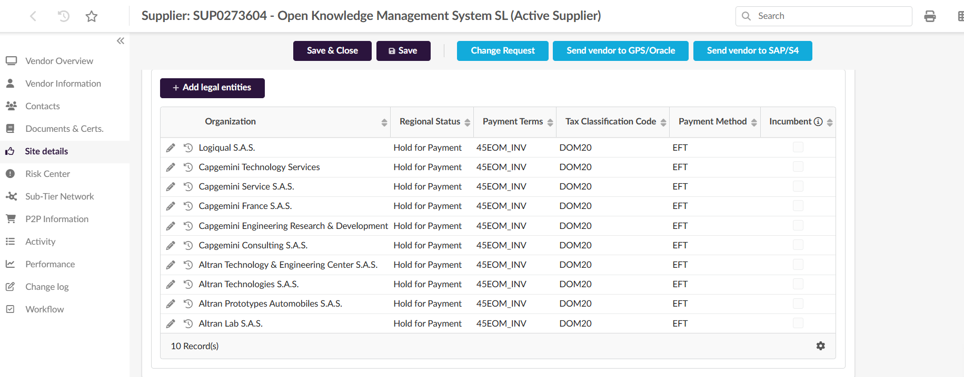

Acceptance Criteria:
AC1 – Expiration Date Reached
Given a supplier is marked as a One-Time Vendor and the expiration date is reached
When the expiration process runs
Then all supplier sites are automatically set to Regional Status = Paysite
AC2 – Vendor Remains Active
Given a supplier is marked as a One-Time Vendor and the expiration date is reached
When the expiration process runs
Then Vendor Global Status remains Active
AC3 – Lock After 180 Days
Given a One-Time Vendor expired more than 180 days ago
When the closure process runs
Then Vendor Global Status is automatically changed to Locked
AC4 – Block Sites After 180 Days
Given a One-Time Vendor expired more than 180 days ago
When the closure process runs
Then all LE/Site statuses are automatically changed to Blocked
AC6 – Closure Reason Assigned
Given a One-Time Vendor expired more than 180 days ago
When the closure process runs
Then Closure Reason is set to "One-Time Vendor – Validity Expired"

Test Cases & Expected Results:
TC--001 – Automatic change of Regional Status to Paysite on expiration date
Steps
- Create or identify a One-Time Vendor.
- Set One-Time Vendor Expiration Date to current date.
- Run expiration batch job (or wait for scheduled execution).
- Review supplier sites.
Expected Result
- All sites have Regional Status = Paysite.
- Vendor Global Status remains Active.
- No manual intervention required.

TC--002 – Vendor Global Status remains Active after expiration
Objective
Verify that expiration does not immediately lock the vendor.
Preconditions
- One-Time Vendor exists.
- Expiration Date = Today.
Steps
- Allow expiration date to be reached.
- Check supplier master record.
Expected Result
- Vendor Global Status = Active.
- Supplier remains searchable.
- Supplier sites are updated to Paysite

TC--003 – Automatic lock 180 days after expiration
Objective
Verify automatic vendor lock after 180 days from expiration.
Preconditions
- Supplier marked as One-Time Vendor.
- Expiration Date passed more than 180 days ago.
- Vendor Global Status = Active.
Steps
- Execute 180-day validation job.
- Review supplier record.
Expected Result
- Vendor Global Status = Locked.
- Locking is performed automatically.

TC--006 – Automatic Site/LE Block after 180 days
Objective
Verify automatic blocking of all supplier sites after 180 days.
Preconditions
- One-Time Vendor expired more than 180 days ago.
Steps
- Execute closure process.
- Open all associated sites.
Expected Result
- LE/Site Status = Blocked for all sites.
- Supplier cannot be used for PR/PO creation.

TC--007 – Closure Reason assigned after 180 days
Objective
Verify the correct Closure Reason is assigned.
Preconditions
- One-Time Vendor expired more than 180 days ago.
Steps
- Execute closure process.
- Review closure information.
Expected Result
- Closure Reason populated automatically.
- Closure Reason = "One-Time Vendor – Validity Expired".

Volume / Frequency (if applicable): to be updated automatically for all vendors with ¨One-Time¨ date, every time a ¨One-Time¨ date expires in SAM.

Reason for the change request (Benefits, What if the CR is not implemented) :
Ensure System behaviour for One time Vendor is in alignemtn with Supplier End to End Lifecycle process released by Group Procurment.
When the One-Time date expires in SAM, the Regional status remains “Hold for Payment” or “Active” however due to end-date the PR/PO creation process is blocked for such a supplier, in that case Regional status provides confusing.
Paysite status will inform that the supplier is inactive for PR/PO creation, however the remaining invoices will be possible to process.

CHANGE REQUEST AMENDMENT
(To be provided by the Change Request Requestor in case of a change in requirement)

Amendment Version:01

Amendment Date:07/15/2026
Amendment Requested By : Anna K, Sanjeev T, Raj Kumar, Maria S
Amendment Approved By :pending
Amendment Description:
One-Time Vendor is a supplier profile created exceptionally for occasional or designated purchases, with short validity period (up to 3 months). It is “infrequent use supplier”, and is systematically deactivated for PR/PO creation after the validity period is completed. System Identification: “One-time vendor” ticked in SAM.

When the One-Time Vendor Expiration Date is reached:
- Change all Regional Statuses of Parent and Child Supplier to Paysite automatically.
- Vendor Global Status remains Active. For both parent and child
- This applies only to vendors correctly tagged as One-Time Vendors and their sites.
- If a Group Supplier is tagged as a One-Time Vendor, this is considered a data quality issue and should be corrected by OBO.
- 180 days after the expiration date:
  - Parent and Child Vendor Global Status changes to Locked automatically
  - Regional Statuses of Parent and Child Supplier changes to Blocked.
  - Closure Reason: One-Time Vendor – Validity Expired.- new Reason for Closure to add in SAM
Note:
- in case the One time vendro expiration date is postponed then the calculation should happen based on the new Validity date.
- Vendor status update should interface to downstream apps, as per the logic existing today.

Attachments:
Acceptance Criteria :

Test Cases & Expected Results:

